Renat Oosthuizen - Glencaldy Learning Centre Design Document

CRC Cards:

|  |  |
| --- | --- |
| Class: Media | |
| Responsibilities:   * Base class for other media types to inherit from * Knows StockID * Knows Title * Knows Price * Knows Publisher * Knows Status (reserved, loaned, available) * Knows Loaner (UserID) * Knows Loan Date | Collaborators:   * Book * Journal * Video * Compact Disk |

|  |  |
| --- | --- |
| Class: Book | |
| Responsibilities:   * Inherits from Media * Knows ISBN * Knows Author * Knows Subject Area * Knows Number of Pages | Collaborators:   * Media |

|  |  |
| --- | --- |
| Class: Journal | |
| Responsibilities:   * Inherits from Media * Knows ISSN * Knows Issue Number * Knows Date of Issue * Knows Subject Area * Knows Number of Pages | Collaborators:   * Media |

|  |  |
| --- | --- |
| Class: Video | |
| Responsibilities:   * Inherits from Media * Knows Running Time * Knows Video Format * Knows Genre * Knows Type of Storage Case | Collaborators:   * Media |

|  |  |
| --- | --- |
| Class: Compact Disk | |
| Responsibilities:   * Inherits from Media * Knows Running Time * Knows CD Type * Knows Number of Tracks * Knows Artist * Knows Type of Storage Case | Collaborators:   * Media |

|  |  |
| --- | --- |
| Class: Generic Member | |
| Responsibilities:   * Base class for other member types * Knows First Name * Knows Surname * Knows initial Password * Knows UserID * Knows Suspended (y/n) * Knows Loaned Items * Knows Fines * Knows Allowed Number of Borrows * Holds Address * Holds Town * Hold Postcode * Holds Telephone Number * Holds Date of Birth | Collaborators:   * Full Member * Casual Member * Staff Member |

|  |  |
| --- | --- |
| Class: Full Member | |
| Responsibilities:   * Inherits from Generic Member | Collaborators:   * Generic Member |

|  |  |
| --- | --- |
| Class: Casual Member | |
| Responsibilities:   * Inherits from Generic Member | Collaborators:   * Generic Member |

|  |  |
| --- | --- |
| Class: Staff Member | |
| Responsibilities:   * Inherits from Generic Member * Holds Admin (y/n) * No Address * No Town * No Postcode * No Date of Birth | Collaborators:   * Generic Member |

|  |  |
| --- | --- |
| Class: Login | |
| Responsibilities:   * Validating login requests * Updating the session file with Login Date and Time, UserID and computerID | Collaborators:   * Full Member * Casual Member * Staff Member * User Menu * Admin Menu |

|  |  |
| --- | --- |
| Class: Create Account | |
| Responsibilities:   * Requests First Name * Requests Surname * Requests Address * Requests Town * Requests Postcode * Requests Telephone Number * Requests Date of Birth * Requests initial Password * Generates UserID * Requests User Type | Collaborators:   * Full Member * Casual Member * Staff Member |

|  |  |
| --- | --- |
| Class: Create Media | |
| Responsibilities:   * Requests Media Type * Requests appropriate information based on media type * Creates new media | Collaborators:   * Book * Journal * Video * Compact Disk |

|  |  |
| --- | --- |
| Class: User Records | |
| Responsibilities:   * Only accessible to admins * Displays user records to admin * Modifies Loaned Items, Suspended, Fine and Admin status of users * Creates new user account by calling Create Account | Collaborators:   * Full Member * Casual Member * Staff Member * Create Account |

|  |  |
| --- | --- |
| Class: Stock Records | |
| Responsibilities:   * Displays stock records * Modify Status between reserved and available (above Casual Member only) * Modifies Status, Loaner and Loan Date of media items (if Admin) * Creates new media items (if Admin) by calling Create Media | Collaborators:   * Book * Journal * Video * Disk |

|  |  |
| --- | --- |
| Class: Member Menu | |
| Responsibilities:   * Menu for Non-Admin Users * Allows Password resetting * Allows reserving an item (if not casual member) via Stock Records * Search catalogue via Stock Records | Collaborators:   * Login * Stock Records |

|  |  |
| --- | --- |
| Class: Admin Menu | |
| Responsibilities:   * Menu for Admin Users * Inherits from Casual Menu * Can do everything | Collaborators:   * Member Menu * Stock Records * User Records |

Use Case Diagram:

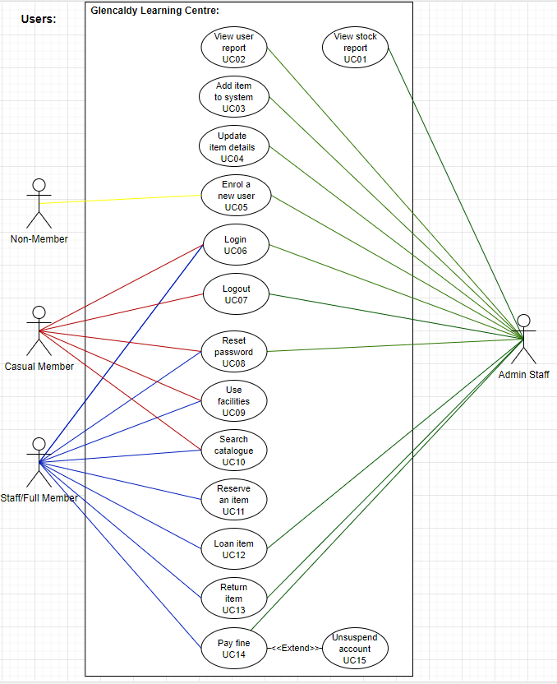

Use Case Descriptions:

|  |  |
| --- | --- |
| Use Case ID: | UC05 |
| Use Case Name: | Enrol a new user |
| Created by: | Renat Oosthuizen |
| Date Created: | 23/11/2020 |
| Actors: | Non-Member  Admin Staff |
| Trigger: | User wants to/needs to become a Member of the Glencaldy Learning Centre |
| Pre-conditions: | - |
| Post-conditions: | * User becomes a Member of the Glencaldy Learning Centre * User does not become a Member of the Glencaldy Learning Centre |
| Normal Flow: | 1. User asks an Admin staff to make them a member of the Member of the Glencaldy Learning Centre. 2. If Admin staff is not logged in, then the Admin staff logs in. 3. Admin staff clicks on View User Records and the Create New Account. 4. Admin staff asks user for account details.    1. If the User provides the account details then the Admin fills those details into the form and submits, creating a new Member account.    2. Else the Admin politely asks the User to leave. |
| Extends (Alternative flows): | - |
| Includes: | - |

|  |  |
| --- | --- |
| Use Case ID: | UC06 |
| Use Case Name: | Login |
| Created by: | Renat Oosthuizen |
| Date Created: | 23/11/2020 |
| Actors: | Casual Member or  Full Member or  Non-Admin Staff Member or  Admin Staff |
| Trigger: | User wants to log into the system. |
| Pre-conditions: | User has been enrolled as a Member of the Glencaldy Learning Centre. |
| Post-conditions: | * Session file is updated with new login data and the user is sent to the menu appropriate for their member type. * User fails to log in. |
| Normal Flow: | 1. User enters UserID and Password into the form.    1. If the UserID/Password combination does not match a valid combination, then display an error message.    2. Otherwise add UserID, ComputerID and current date and time to the session.log file. Then, display the menu appropriate for the member type. |
| Extends (Alternative flows): | - |
| Includes: | - |

|  |  |
| --- | --- |
| Use Case ID: | UC12 |
| Use Case Name: | Loan item |
| Created by: | Renat Oosthuizen |
| Date Created: | 23/11/2020 |
| Actors: | Full Member or  Non-Admin Staff Member or  Admin Staff Member  Admin Staff |
| Trigger: | User wants to loan an item. |
| Pre-conditions: | User has found an item they wish to loan. |
| Post-conditions: | User and stock records are updated. The loan(s) is approved.  The loan is not approved. |
| Normal Flow: | 1. User brings an item/items to an Admin Staff Member. 2. If Admin staff is not logged in, then the Admin staff logs in. 3. Admin clicks on View User Report and checks if the user’s account is suspended and how many more books they can loan.    1. If the account is suspended or they have reached their loan allowance, then the loan is denied. 4. Admin returns to menu and clicks on View Stock Report. Then checks if the media items are reserved.    1. If all media items are reserved, then the loan is denied.    2. If the number of items they wish to borrow is within their total loan allowance and none are reserved, then the loan is approved.    3. Else the user selects which items they wish to loan out of those which are not reserved to stay within their loan allowance. The Admin staff updates the items page(s) to reflect the loan in the Stock Report. Admin Staff returns to the menu, clicks View User Report and updates the user account to reflect the loan. |
| Extends (Alternative flows): | - |
| Includes: | - |

|  |  |
| --- | --- |
| Use Case ID: | UC14 |
| Use Case Name: | Pay fine |
| Created by: | Renat Oosthuizen |
| Date Created: | 23/11/2020 |
| Actors: | Full Member or  Non-Admin Staff Member or  Admin Staff Member  Admin Staff |
| Trigger: | User wants to pay a fine |
| Pre-conditions: | User has not returned an item within the 10-day period |
| Post-conditions: | * User’s fine is set to £0. * User’s fine is unchanged. * User’s fine is set to £0 and their account is unsuspended. |
| Normal Flow: | 1. User approaches a staff member and asks to pay a fine. 2. If Admin staff is not logged in, then the Admin staff logs in. 3. Admin staff clicks on Check User Records and finds out if the user has a fine and what the user fine is.    1. If the user has no fine, then no changes are made.    2. If the user refuses to pay the fine or wants to pay it partially, then no changes are made.    3. If the fine is below £4.00 and the user pays the fine, then the Admin takes the money and set’s the user’s fine to £0. |
| Extends (Alternative flows): | UC15: If the fine is equal to or above £4.00, the Admin takes the money, set’s the user’s fine to £0 and changes the user’s Suspended status to N. |
| Includes: | - |